1. Single Inheritance – Scenario
Scenario:
A company has a Vehicle class with methods startEngine() and stopEngine(). A Car
class extends Vehicle and adds a playMusic() method.
The company now wants every car to automatically log the engine start time whenever
startEngine() is called, while still using the original engine-start functionality.
CODE:
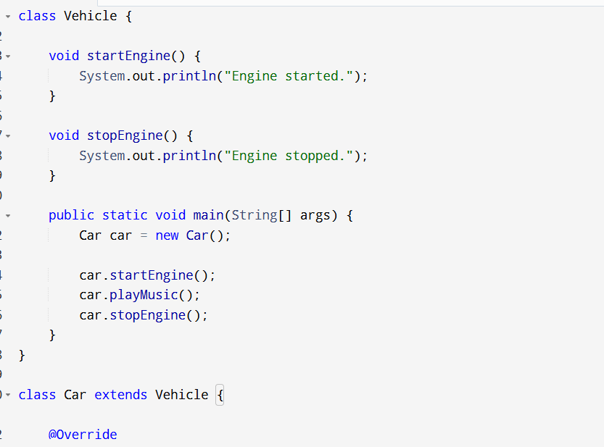
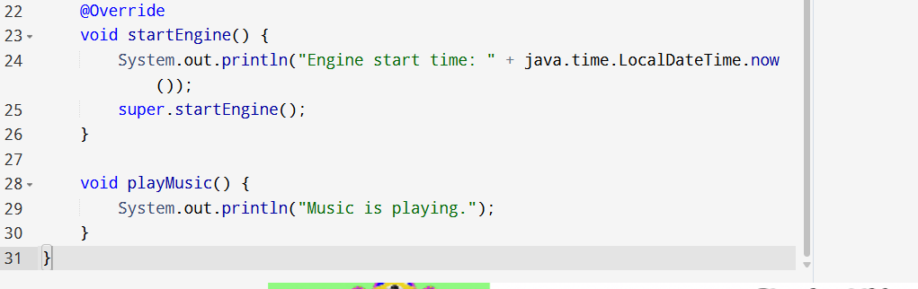OUTPUT:
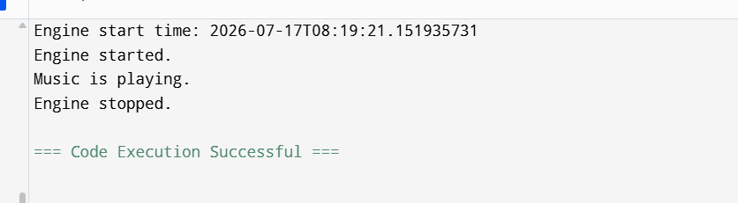
1: How would you implement this using single inheritance?
Use single inheritance, where Car inherits from Vehicle. The Car class overrides the startEngine() method to add logging functionality and then calls the parent class method using super.startEngine().
2: Should Car override startEngine()? Why?
Yes.
Reason:
- The company wants every car to log the engine start time whenever the engine starts.
- Overriding allows the Car class to add this new behavior while keeping the original functionality.

3.How can the parent class implementation still be executed?
- Use the super keyword.
- super.startEngine();
- This calls the startEngine() method of the Vehicle class after performing the additional logging.
4. What happens if Car does not override startEngine()?
If Car does not override startEngine():
- The inherited Vehicle version is executed.
- The engine starts normally.
- No engine start time is logged, because the additional functionality is missing.

2. Multilevel Inheritance – Scenario
Scenario:
A software company models employees as follows:
• Employee → stores employee ID and name.
• Developer extends Employee → stores programming language.
• SeniorDeveloper extends Developer → stores team size and performs code
reviews.
Now HR requests that every SeniorDeveloper should be able to access employee
information and programming language details without duplicating code.
CODE:
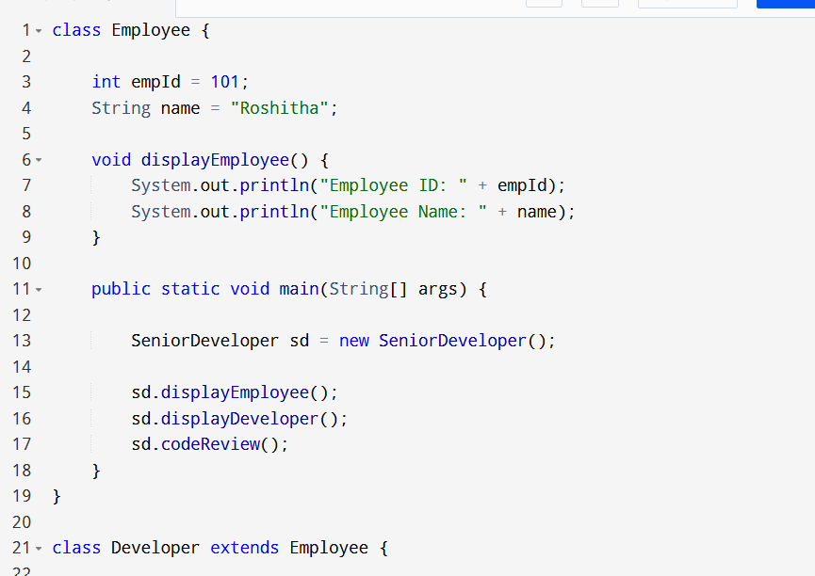
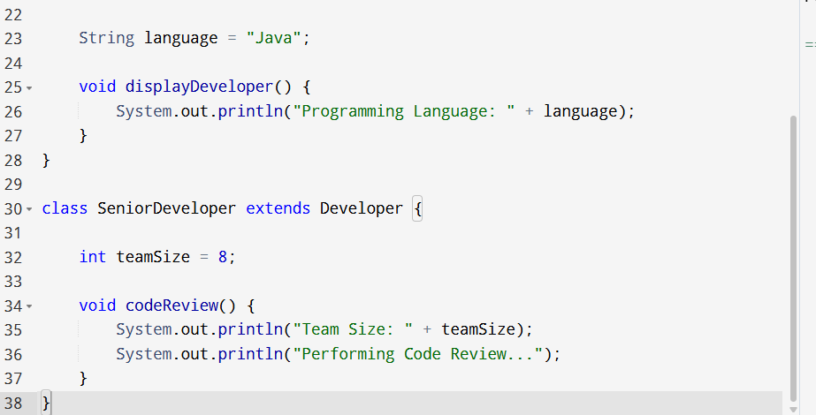
OUTPUT:
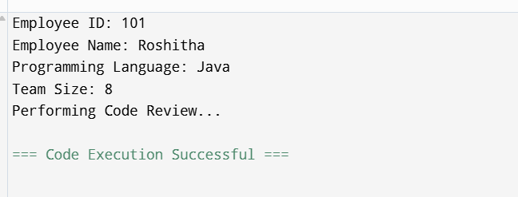
1. Why is multilevel inheritance suitable here?
Multilevel inheritance is suitable because each class adds new features without repeating code. SeniorDeveloper inherits the employee details from Employee and programming language from Developer, promoting code reuse.
2. Which members are accessible in SeniorDeveloper?
SeniorDeveloper can access:
- From Employee
  - empId
  - name
  - displayEmployee()
- From Developer
  - language
  - displayDeveloper()
- From SeniorDeveloper
  - teamSize
  - codeReview()

3. If Developer overrides a method from Employee, which implementation will SeniorDeveloper inherit?
- SeniorDeveloper inherits the overridden method from Developer because the closest overridden method in the inheritance chain is used.
Example:
Employee → display()
Developer → display() (overridden)
SeniorDeveloper → uses Developer's display()

4.Draw the inheritance hierarchy
Employee
│
▼
Developer
│
▼
SeniorDeveloper

3. Hierarchical Inheritance – Scenario
Scenario:
An online shopping application has a base class Payment.

Three classes inherit from it:
• CreditCardPayment
• UPIPayment
• NetBankingPayment
Each payment type processes transactions differently but shares common validation logic.
CODE:
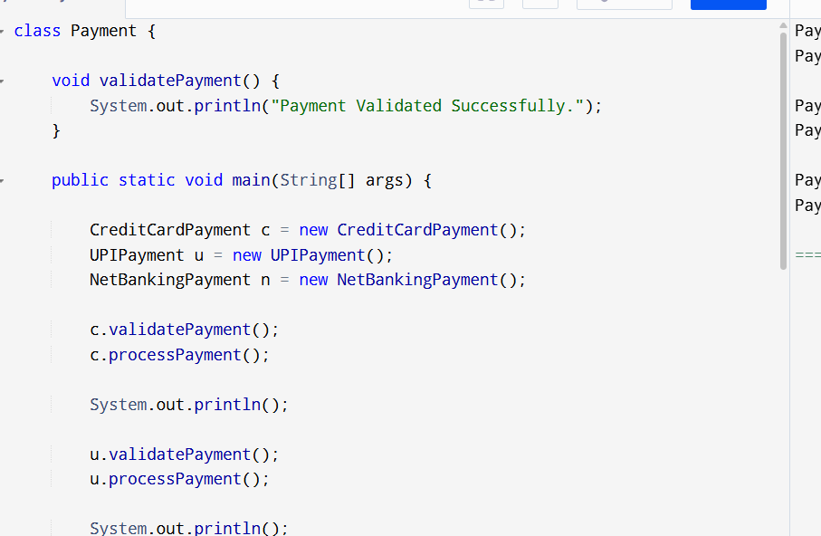
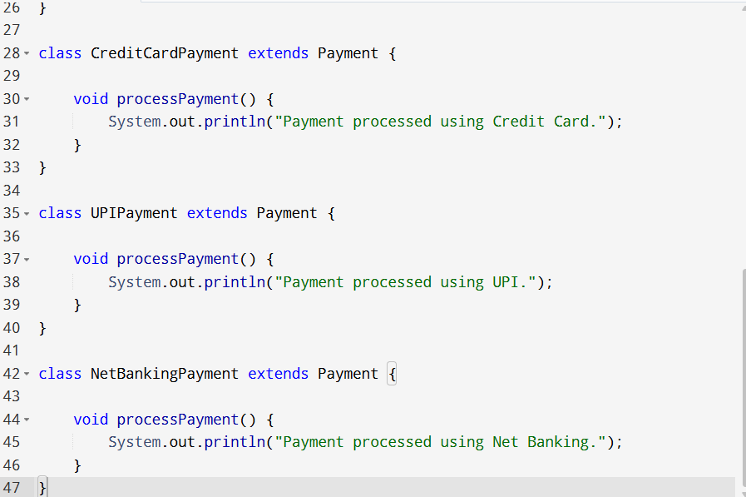OUTPUT
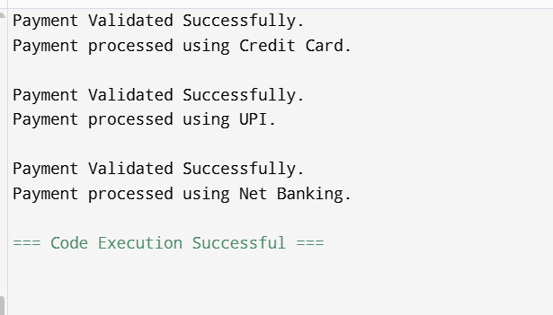
1. Why is hierarchical inheritance appropriate here?
Hierarchical inheritance is appropriate because multiple classes (CreditCardPayment, UPIPayment, and NetBankingPayment) inherit common features from a single base class (Payment). This avoids code duplication.

2. Where should common validation logic be implemented?
The common validation logic should be implemented in the Payment class so that all child classes can reuse it.

3. How can each payment class provide its own transaction processing?
Each child class defines its own processPayment() method with its specific implementation.
Example:
- CreditCardPayment → Processes payment using a credit card.
- UPIPayment → Processes payment using UPI.
- NetBankingPayment → Processes payment using net banking.

4. What is the advantage over writing three independent classes?
- Reduces code duplication.
- Promotes code reuse.
- Easier to maintain and update.
- Common functionality is written only once in the parent class.
4. Compile-Time Polymorphism (Method Overloading) –
Scenario
A calculator application supports addition of:
• Two integers
• Three integers
• Two decimal numbers
The product owner wants users to call the same method name (add) regardless of the input.
CODE:
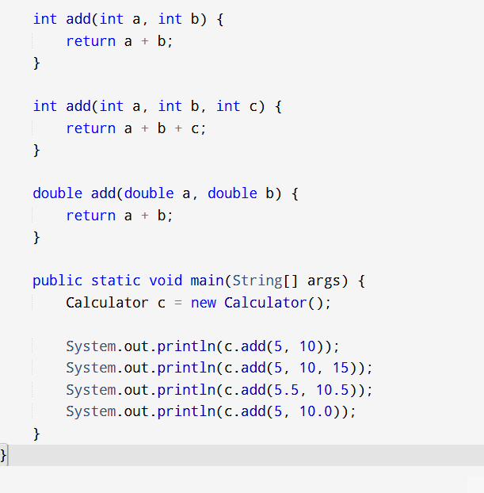
OUTPUT:
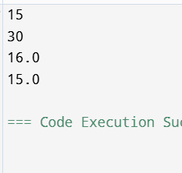
1. Which OOP concept should be used?
Use Compile-Time Polymorphism (Method Overloading).
- Multiple methods have the same name (add) but different parameter lists.
- This allows users to call the same method name with different inputs.

2.How will Java decide which method to invoke?
Java checks the number, type, and order of parameters at compile time.

3. Can methods be overloaded by changing only the return type?

NO
- Changing only the return type causes a compile-time error because Java cannot distinguish methods based only on return type.
4.What happens if add(5, 10.0) is called?
Answer:
Java performs automatic type promotion.
- 5 (int) is converted to 5.0 (double).
- The method add(double, double) is invoked.
5. Runtime Polymorphism (Method Overriding) –
Scenario
A food delivery application has:
Restaurant
|

-------------------------
| | |
Pizza Burger Biryani
Each restaurant calculates delivery time differently.
The application stores all restaurants in:
List&lt;Restaurant&gt; restaurants;
and calls:
restaurant.calculateDeliveryTime();
without checking the actual restaurant type.

CODE:
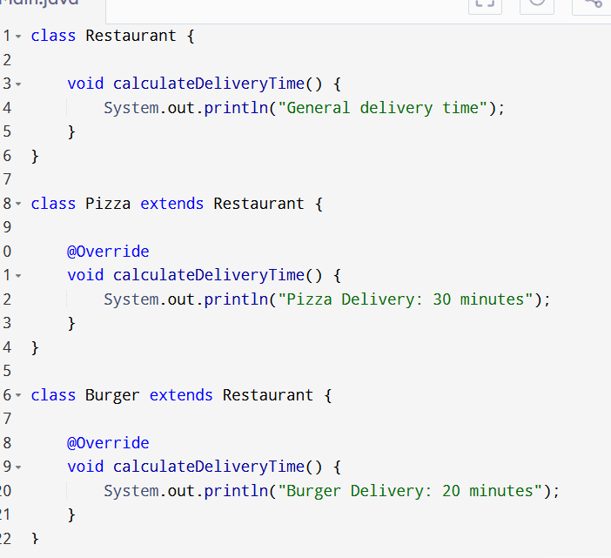
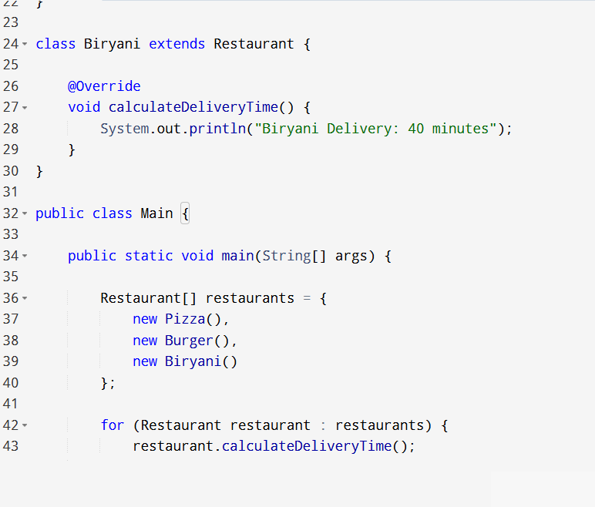

OUTPUT:
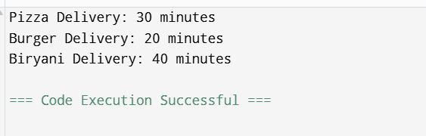
1. Which OOP concept is being used?
Answer:
The OOP concept used is Runtime Polymorphism (Method Overriding).
- The base class is Restaurant.
- The subclasses (Pizza, Burger, and Biryani) override the calculateDeliveryTime() method.
- The same method call executes different implementations depending on the actual object.
2. Which version of calculateDeliveryTime() executes?
Answer:
The overridden method of the actual object executes.
For example:
- If the object is Pizza, Pizza's calculateDeliveryTime() method is called.
- If the object is Burger, Burger's method is called.
- If the object is Biryani, Biryani's method is called.
Java determines this based on the object's actual type at runtime.
3. When is the method selection decided?
Answer:
The method selection is decided at runtime.
This is called Dynamic Method Dispatch, where Java checks the actual object type during program execution and invokes the appropriate overridden method.
4. What would happen if calculateDeliveryTime() were declared static?
Answer:
If calculateDeliveryTime() were declared as static, it cannot be overridden.
- Static methods belong to the class, not the object.
- The method call is resolved at compile time based on the reference type.
- Runtime polymorphism would not occur.
Example:
Restaurant restaurant = new Pizza();
restaurant.calculateDeliveryTime();
If the method is non-static, the output is:
Pizza Delivery: 30 minutes
If the method is static, Java calls:
Restaurant.calculateDeliveryTime()
instead of Pizza.calculateDeliveryTime(), because static methods are bound to the class rather than the object.

6. Interface – Scenario
Scenario:
A smart home application supports different devices:
• Smart Bulb
• Smart Fan
• Smart AC
All devices can be turned on and turned off, but each device has its own implementation.
In the future, third-party manufacturers should also be able to integrate their own devices
without modifying existing code.
CODE:
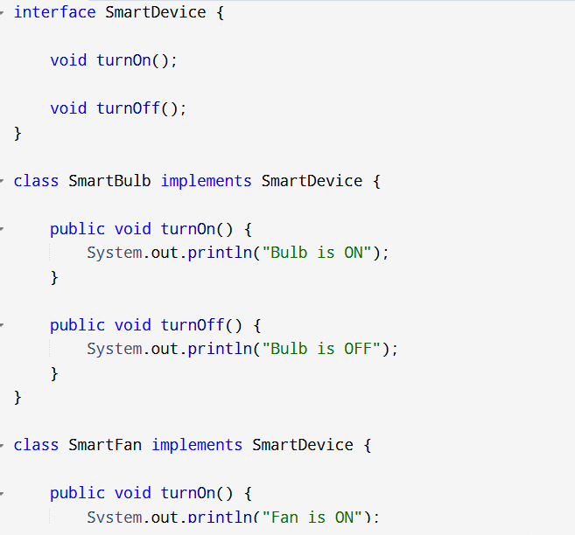
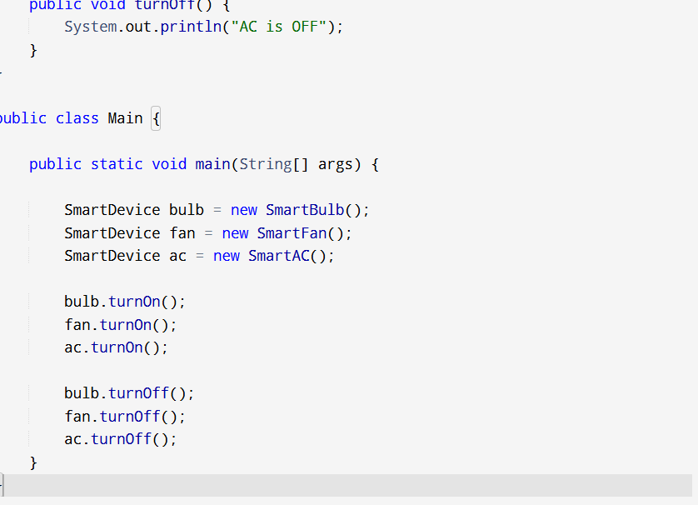OUTPUT:
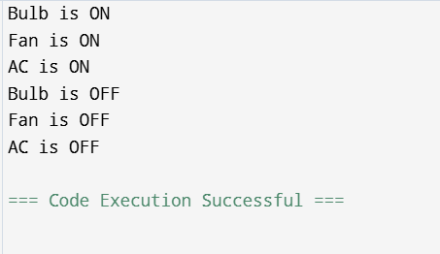
1. Would you use an interface or inheritance? Why?
Answer:
Use an interface because all devices have the same functions (turnOn() and turnOff()) but different implementations. It also allows new devices to be added easily.
2. Design an appropriate interface.
Answer:
interface SmartDevice {
void turnOn();
void turnOff();
}
3. Can one device implement multiple interfaces? Give an example.
Answer:
Yes. A device can implement multiple interfaces.
Example:
class SmartAC implements SmartDevice, WiFiEnabled {
public void turnOn() {}
public void turnOff() {}
public void connectWiFi() {}
}
4. Why is an interface better than creating a common base class in this scenario?
Answer:
- Supports multiple interfaces.
- Allows different implementations.
- Easy to add new devices.
- Makes the application flexible and maintainable.

